Religion and Media
Summer Semester 2019

Wednesday 2:00- 4:00
Uni90a, 0/013
3 credit points/ 6 credit points

Instructor: Giulia Evolvi
Email: giulia.evolvi@rub.de
@giuliaevolvi
www.giuliaevolvi.com

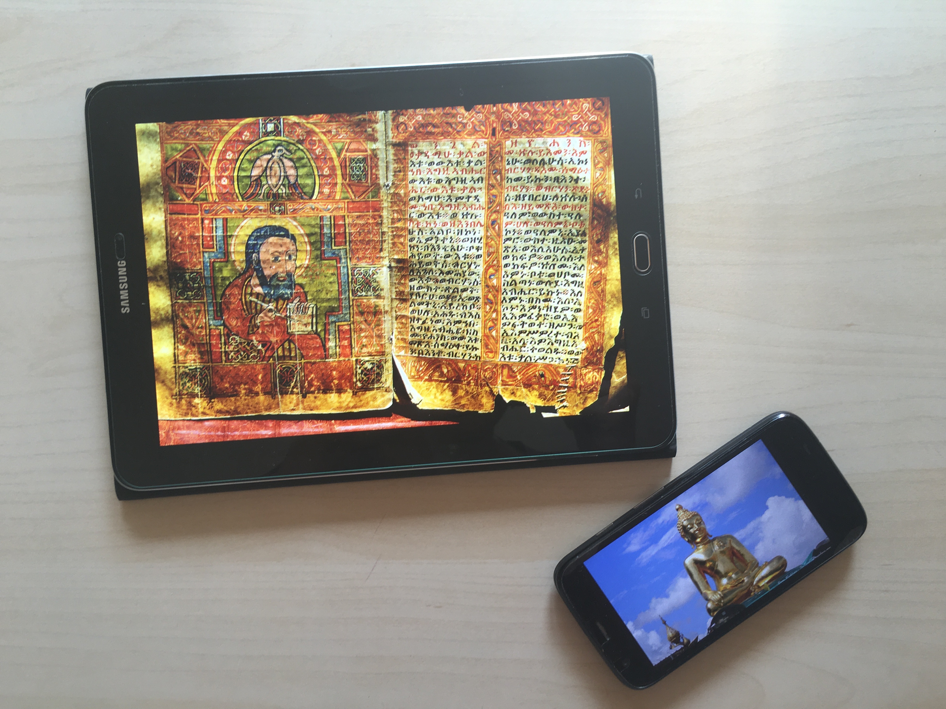

Course Description

How do religious groups communicate their messages to other groups? Which media do they use to spread their ideas? How do media talk about religion?
This class explores these questions (and many others) by analyzing a wide range of media forms: from scrolls to sacred images, from printing press to television, from radio to smartphone apps. Students will talk about theories and traditions that focus on religion and media, including technological determinism, cultural studies, material and visual culture, mediation, mediatization, social shaping of technology. At the end of the semester, students will be able to critically think about religion and media both in historical and contemporary settings, and to recognize the important effects of media on religion (and vice versa). The class aims at students who are interested in becoming art historians, religious journalists, cultural mediators, or who want in general to understand the fundamental relation of media and religion.

Course Plan

3 April
Introduction to the class
Reading: Hoover, Stewart M. Religion in the Media Age. 1 edition. London ; New York: Routledge, 2006. Pp. 7-26

10 April
Religion and Material Culture
Reading: Morgan, David. 2016. “Material Analysis and the Study of Religion” in Materiality and the Study of Religion: The Stuff of the Sacred, edited by Tim Hutchings and Joanne McKenzie. New York: Theology and Religion in Interdisciplinary Perspective Series in Association With the Bsa Sociology of Religion Study Group.

17 April
Religion and Mediation
Reading: Meyer, Birgit, "Religious Sensations: Why Media, Aesthetics and Power Matter in the Study of Contemporary Religion," Inaugural Lecture, Free University of Amsterdam, 2005.

24 April
Religion as Communication
Reading: Carey, James. “A Cultural Approach to Communication” in Communication as Culture: Essays on Media and Society. Boston: Unwin-Hyman, 1988.

8 May
Religion and Media History
Reading: Horsfield, Peter, “The Ecology of Writing and the Shaping of Early Christianity,” in Knut Lundby (ed.), Religion Across Media: From early antiquity to late modernity. New York, Peter Lang, 2013.
OR
Shaked, Shaul. “Orality and Esotericism: Reflections on Modes of Transmission in Late Antiquity” in Rubanovich, Julia (ed.) “Orality and Textuality in the Iranian World: Patterns of Interaction Across Centuries,” Brill Publishing. 2015.

15 May
Religion and Media Institutions
Hjarvard, Stig. “From Mediation to Mediatization: The Institutionalization of New Media.” In: Hepp A., Krotz F. (eds) Mediatized Worlds. Palgrave Macmillan, London. 2014.

22 May
Religion and Representation
Reading: Hall, Stuart. “The White of Their Eyes: Racist Ideologies and the Media” in Alvarado M and Thompson J (eds) The Media Reader, London: BFI. 1990

29 May
Religion and Media Events
Reading: Dayan, Daniel, and Elihu Katz. Media Events: The Live Broadcasting of History. Reprint edizione. Cambridge, Mass.: Harvard Univ Pr, 1994. Pp 1-25

Discussion about Final Paper

5 June
Religion and (Hyper)Reality
Reading: Baudrillard, Jean. Simulacra and Simulation. Selected Writings, ed. Mark Poster (Stanford; Stanford University Press, 1988), pp.166-184.

19 June
Religion and the Internet
Reading: Campbell, Heidi. When Religion Meets New Media: Media, Religion and Culture. 1st ed. London ; New York: Media, Religion and Culture, 2007. Pp. 1-18, 41-64

26 June
No Class, Meeting with Dr. Evolvi about Final Paper

3 July
Religion and (Digital) Space
Reading: Hoover, Stewart and Echchaibi, Nabil. “Media Theory and the “Third Spaces of Digital Religion,” Working Paper Center for Media, Religion, and Culture. 2014.

Concluding Remarks & Discussion about Final Paper

10 July
No Class, Working on Final Paper

1st September: Deadline for Final Paper

I will electronically distribute articles and book chapters that you are required to read each week.
Please note that the course schedule may slightly change, and I will communicate changes via email in a timely manner.

Evaluation

Grades will be determined by:

- Attendance and Participation: You will be evaluated in terms of class attendance and class discussion. The language of discussion is English, but students’ language skills will not influence the grade. Please let me know if you need to come to class late or leave early, and if you need to skip class. You need to do the readings at home and come prepared to discuss them with meaningful questions and comments. There are no right or wrong answers, and remember that civility in the classroom and respect for the opinions of your classmates are very important in an academic environment. (3 credit points)

- Final Paper: You need to write a final paper on Religion and Media presenting an historical or contemporary example and critically engaging with the theories and readings done in class. You will be requested do some additional readings I will help you choose. The final paper will be 3500-5000 words plus notes and references. During the semester, I will explain what I expect from your paper and give you individual feedback on your topic. I will provide specific guidelines for quotations during the semester. The deadline for the paper is the 1st of September. Please let me know in advance if you need an extension. Life if messy and things happen, but permission is always easier to obtain than forgiveness. (3 credit points)

The overall class grade will be assigned in accordance with the following criteria:
- 1,0–1,5 sehr gut : you always come prepared to class. Your questions and comments are pertinent, you always pay attention, and you engage with your peers’ ideas. Your final paper is well-written and well-researched, and your argument is clear and compelling. Good job!
- 1,6–2,5 gut: you did all the required readings and often are ready to discuss them. You have many good ideas and you can connect them with the topics discussed in class, you only need to do an extra effort to have your intellectual voice emerge. You’re almost there!
- 2,6–3,5 befriedigend: you pay attention in class and are able to follow the discussions. The paper is overall well-written, and with some more coursework and readings you will develop your ideas in a coherent and relevant way. Feel free to come and see me to discuss how you can make your work really awesome.
- 3,6–4,0 ausreichend: you come to class and participate, but sometimes get distracted. The paper is based on good ideas, but it is not very clear and it seems you need to do some extra work. You are welcome to see me to talk about how you can improve your work.
- 5,0 nicht ausreichend / nicht bestanden: you barely come to class and often you do not to the readings or are unable to discuss them. You did not turn the final paper in or it is very poorly written. Maybe this wasn’t the class for you? I will be happy to meet with you and understand why.
Classroom Etiquette

Use of Mobile Devices, Laptops and Tablets during Class
This is a media and religion class, so you are welcome to bring computers or tablets in class. However, they cannot be used for any activity not related to class, because they can affect everyone’s learning experience.

Email
I only answer my emails in the morning and in the evening, and I never check my emails on week-ends. If you have a very urgent matter, please say so in the email object. If you have multiple questions about the material, or need extra help, please come and see me during office hours.

Course policies
Students and faculty each have responsibility for maintaining an appropriate learning environment. Those who fail to adhere to such behavioral standards may be subject to discipline. Professional courtesy and sensitivity are especially important with respect to individuals and topics dealing with differences of race, color, culture, religion, creed, politics, sexual orientation, gender, gender identity and gender expression, age, disability, and nationalities. Class rosters are provided to the professor with the student's legal name. I will gladly honor your request to address you by an alternate name or gender pronoun. Please advise me of this preference early in the semester so that I may make appropriate changes to my records.

Academic Dishonesty and Plagiarism
Academic dishonesty is defined as cheating, plagiarism, unauthorized collaboration, falsifying academic records, and any act designed to avoid participating honestly in the learning process. Scholastic dishonesty also includes, but is not limited to, providing false or misleading information to receive a postponement or an extension on assignments. By accepting this syllabus, you have agreed to these guidelines and must adhere to them. Scholastic dishonest damages both the student's learning experience and readiness for the future demands of a work-career.

Accommodations for students
If you qualify for accommodations, please contact me in a timely manner so that your needs can be addressed. I will make every effort to deal reasonably and fairly with all students who, because of religious obligations, have conflicts with scheduled assignments or required attendance.

